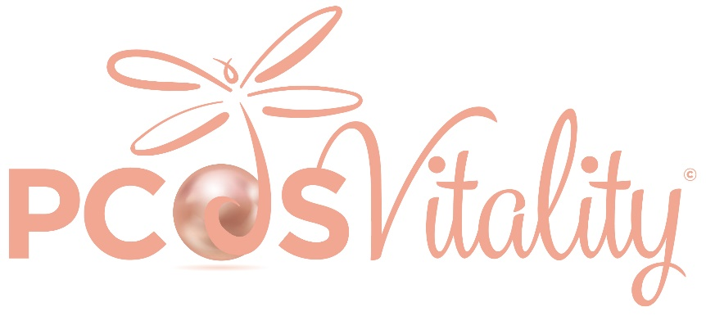
PCOS CONSULTATION TIPS
BEFORE THE APPOINTMENT

Keep a symptoms diary so you can note any patterns that may emerge in the run-up to your appointment. Note when your symptoms started or worsened & anything you noted that coincided with the changes.
Prepare questions you may want to cover (what is the main reason for your visit? – consult the PCOS Question Prompt List [1]
You can download it by copying and pasting the link below into your internet browser:
https://www.monash.edu/medicine/sphpm/mchri/pcos/resources/pcos-question-prompt-list
Bring a copy of your symptom checklist (see PCOS symptom checklist).
Make a list of all your current medications and doses including any supplements or herbal treatments you are currently taking.
Bring any notes on your menstrual cycle, menstrual irregularities, bleeding problems, & significant dates.
Ask a friend or family member to accompany you if you feel you need it.

AT THE APPOINTMENT

Take your time and breathe. Ask your questions [2] – if you have brought a list, tick each point off during the appointment. Do not be afraid to ask for an explanation of anything you do not understand. Ask them to explain any words you are not familiar with or ask for them to write them down.
Some questions you may like to ask could include some of the following examples
What are the tests for? (Usually blood tests are taken to measure Total Testosterone, SHBG, to Calculate Free Androgen Index and to rule out other causes of irregular or missing periods by testing LH and FSH, Prolactin and TSH or your Dr may include others).[3]
Are there other ways to treat my condition?
Are there any side effects or risks? How long will I need treatment for? How effective is the treatment?
Are there any alternatives or what will happen if I do not have any treatment?
What happens next? Do I need to come back and see you? Where can I get more information?

AFTER YOUR APPOINTMENT

It can be useful to note what was discussed. Book any tests you need and put the dates in your diary. Follow up on test results and keep a note of them in your records/symptoms diary. Take time to process the information. PCOS is a complex condition, you may wish to talk over things with a friend, partner, family member or other PCOS friend.
PCOS SYMPTOMS CHECKLIST
You must never try to diagnose yourself with PCOS. It is very important to seek medical diagnosis as PCOS is a diagnosis of exclusion which means other possible conditions need to be ruled out. This information is for guidance only to help you record symptoms to bring with you to your Drs appointment.

PCOS has many signs and symptoms in addition to the three classical features of PCOS which are missing periods, high androgen levels and cysts (immature follicles) on the ovaries and some of these may not, initially, seem to be related but can include:

POSSIBLE PCOS SYMPTOMS
Frequently missed periods
Very heavy periods
Bleeding monthly but no signs of ovulation (no egg released/difficulty trying to conceive)
Excess facial hair/neck hair
Excess hair on the body – sometimes on chest, stomach, thighs but this varies slightly
Severe acne and/or oily skin
Weight gain (particularly in lower abdomen)
Difficulty losing weight
Obesity
Thickened, dark, velvety skin (acanthosis nigricans) usually on back of neck and in armpits
Skin tags
Thinning hair on head (particularly the front/top)
Emotional problems (anxiety, depression)
Recurrent miscarriages
Fatigue/Sleep Apnea
References
[1] PCOS Question Prompt List - Monash Centre for Health Research and Implementation (MCHRI), (n.d.). https://www.monash.edu/medicine/sphpm/mchri/pcos/resources/pcos-question-prompt-list (accessed April 30, 2022).
[2] What to ask your doctor - NHS, (n.d.). https://www.nhs.uk/nhs-services/gps/what-to-ask-your-doctor/ (accessed April 29, 2022).
[3] Polycystic ovary syndrome - NICE CKS, (n.d.). https://cks.nice.org.uk/polycystic-ovary-syndrome#!scenario (accessed November 16, 2019).

© PCOS Vitality 2022. DISCLAIMER: Not medical advice. Always consult your Dr. PCOS Vitality do not recommend any treatment or course of action. Do not under any circumstances diagnose yourself – always seek medical attention. Special thanks to Daisy PCOS Leaders for their contributions. Sincere thanks to Symone Collicutt and Hannah Hegarty from Daisy PCOS Leaders Team and Dr P Kempegowda for their contributions to this guide.

